Use case diagram:
A use case diagram is a graphic depiction of the interactions among the elements of a system. A use case is a methodology used in system analysis to identify, clarify, and organize system requirements. ... The use cases, which are the specific roles played by the actors within and around the system.
Use case diagrams are typically develop in early stage of development and people often apply use case modeling for the following purposes:
- Specify the context of a system
- Capture the requirements of a system
- Validate a systems architecture
- Drive implementation and generate test cases
- Developed by analysts together with domain experts
Boundary of system
- The system boundary is potentially the entire system as defined in the requirements document.
- For large and complex systems, each modules may be the system boundary.
- For example, for an ERP system for an organization, each of the modules such as personal, payroll, accounting, etc.
- can form a system boundary for use cases specific to each of these business functions.
- The entire system can span all of these modules depicting the overall system boundary

Include
- When a use case is depicted as using functionality of another functionality of another use case, this relationship between the use cases is named as an include or uses relationship.
- A use case includes the functionality described in another use case as a part of its business process flow.

Import Data
Preprocessing
Data Cleaning
Training Data
Testing Data
Training Base Predictors
Classification
Sequence Diagram:
A sequence diagram shows object interactions arranged in time sequence. It depicts the objects and classes involved in the scenario and the sequence of messages exchanged between the objects needed to carry out the functionality of the scenario. Sequence diagrams are sometimes called event diagrams or event scenarios.
Sequence Diagrams captures:
- the interaction that takes place in a collaboration that either realizes a use case or an operation (instance diagrams or generic diagrams)
- high-level interactions between user of the system and the system, between the system and other systems, or between subsystems (sometimes known as system sequence diagrams)

Preprocessing
Preprocessing
Stemming
Words
Data Cleaning

Data Cleaning
Training Data
Directed Acyclic
Graph (Dag):
Testing Data

Training Base
Predictors
Training Base
Predictors
Data gathering methods
Representation and quality of data is first
Data Preprocessing
Pre cleanning data
Remove the noisy data
Correct the inconsistencies in data
Different subsets of upi Classification
Train data using CNN
UPI Fraud Prediction
Architecture Diagram:
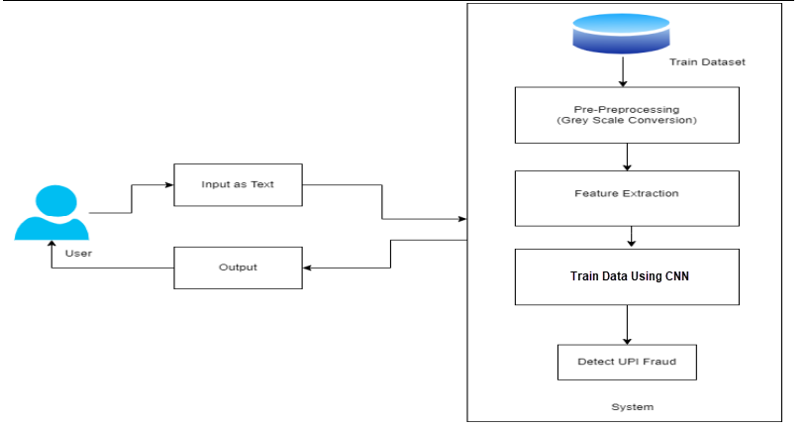

Data Flow Diagram:
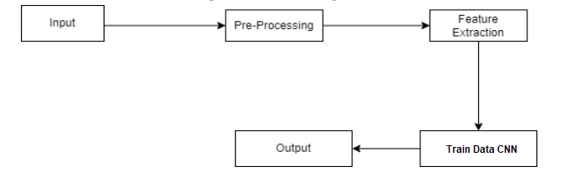

1. UPI FRAUD DETECTION DATA VISUALIZATION
<h1>UPI Fraud Detection Using Machine Learning Approaches</h1>

<!-- Google Charts for Data Visualization -->
<script type="text/javascript" src="https://www.gstatic.com/charts/loader.js"></script>
<script type="text/javascript">
google.charts.load("current", { packages: ['corechart'] });

// Bar Chart for Transaction Categories
google.charts.setOnLoadCallback(function () {
var data = google.visualization.arrayToDataTable([
["Category", "Transactions", { role: "style" }],
["Free_Money", 182, "#00FFFF"],
["Stalking", 175, "#DF01A5"],
["Investment", 160, "#FF0000"],
["Job_Opening", 154, "color: #FFBF00"]
]);

var options = { title: "Transaction Categories", width: 600, height: 400 };
var chart = new google.visualization.ColumnChart(document.getElementById("columnchart_values"));
chart.draw(data, options);
});
// Pie Chart for Fraud vs Non-Fraud Transactions
google.charts.setOnLoadCallback(function () {
var data = google.visualization.arrayToDataTable([
["Type", "Percentage"],
["Fraud", 35],
["Real", 75]
]);

var options = { title: "Fraud vs Non-Fraud Transactions", is3D: true };
var chart = new google.visualization.PieChart(document.getElementById("piechart_3d"));
chart.draw(data, options);
});
// Line Chart for Accuracy Plot
google.charts.setOnLoadCallback(function () {
var data = new google.visualization.DataTable();
data.addColumn('string', 'Epochs');
data.addColumn('number', 'Training Accuracy');
data.addColumn('number', 'Testing Accuracy');

data.addRows([
['10', 0.75, 0.74],
['20', 0.82, 0.81],
['30', 0.85, 0.86],
['40', 0.92, 0.93],
['50', 0.995, 0.998]
]);

var options = {
title: "Accuracy Plot",
hAxis: { title: 'Epochs' },
vAxis: { title: 'Accuracy' },
width: 550,
height: 400
};
var chart = new google.visualization.LineChart(document.getElementById('container'));
chart.draw(data, options);
});
</script>

2. UPI FRAUD DETECTION ABSTRACT PAGE
<!DOCTYPE html>
<html lang="en">

<head>
<meta charset="utf-8">
<meta name="viewport" content="width=device-width, initial-scale=1.0">
<title>UPI Fraud Detection</title>

<!-- Google Fonts -->
<link href="https://fonts.googleapis.com/css?family=Open+Sans|Raleway|Poppins" rel="stylesheet">

<!-- Bootstrap CSS -->
<link href="../static/vendor/bootstrap/css/bootstrap.min.css" rel="stylesheet">

<!-- Main CSS -->
<link href="../static/css/style3.css" rel="stylesheet">
</head>

<body>
<!-- Header -->
<header id="header" class="d-flex align-items-center">
<div class="container d-flex justify-content-between">
<h1><a href="index.html">UPI Fraud Detection</a></h1>
<nav>
<ul>
<li><a href="{{ url_for('first')}}">Home</a></li>
<li><a href="{{ url_for('login')}}">Login</a></li>
</ul>
</nav>
</div>
</header>

<!-- Hero Section -->
<section id="hero" class="d-flex align-items-center">
<div class="container text-center">
<h1>UPI Fraud Detection Using Machine Learning</h1>
<a href="#about" class="btn btn-primary">Abstract</a>
</div>
</section>

<!-- Abstract Section -->
<section id="about" class="about">
<div class="container">
<h3 class="text-center">Abstract</h3>
<p> UPI Fraud is becoming more common in financial transactions. Conventional methods rely on rule-based systems, overlooking diverse situations and imbalances in data. This paper proposes a CNN-based framework to detect fraud, leveraging intrinsic patterns in transaction data. Experiments demonstrate its superior performance compared to state-of-the-art methods.</p>
</div>
</section>
</body>
</html>

3. FRONTEND UI FOR UPI FRAUD DETECTION
<h1>UPI Fraud Detection</h1>
<section id="hero" class="d-flex align-items-center">
<div class="container d-flex flex-column align-items-center">
<h1>UPI Fraud Detection</h1>
<h2>I'm a Professional Detector using Machine Learning</h2>
</div>
</section>

<div class="container register-form">
<div class="form-content">
<form action="/detect" method="post">
<div>
<input type="number" name="card_number" placeholder="Enter UPI number"/>
<input type="text" name="card_holder_name" placeholder="UPI holder name" />
<input type="text" name="dob" placeholder="Enter date of Birth" onfocus="(this.type='date')" required />
<select name="state" required>
<option selected disabled value="">Select state</option>
<option value="10">Karnataka</option>
<option value="11">Kerala</option>
<option value="23">Telangana</option>
<!-- Add other states as needed -->
</select>
<input type="number" name="zip" placeholder="Enter pin code" required />
<input type="text" name="trans_datetime" placeholder="Enter date and time" onfocus="(this.type='datetime-local')" required />
<input type="number" name="trans_amount" placeholder="Enter transaction amount (Rs)" required />
<select name="category" required>
<option selected disabled value="">Select merchant category</option>
<option value="0">Entertainment</option>
<option value="1">Food Dining</option>
<option value="13">Travel</option>
</select>
<button type="submit">Click to Detect</button>
</div>
</form>
</div>
</div>

4. RESULT PAGE FOR UPI FRAUD DETECTION
<!DOCTYPE html>
<html lang="en">

<head>
<meta charset="utf-8">
<meta name="viewport" content="width=device-width, initial-scale=1, shrink-to-fit=no">
<title>UPI Fraud Detection</title>
<link rel="stylesheet" href="https://maxcdn.bootstrapcdn.com/bootstrap/4.0.0/css/bootstrap.min.css" crossorigin="anonymous">
<link href="../static/css/result.css" type="text/css" rel="stylesheet">
</head>

<body>
<div class="container register-form">
<div class="heading">
<p>RESULT</p>
</div>
<div class="form-content">
<div class="col-md-12">
<div class="form-group">
<p id="output">{{OUTPUT}}</p>
</div>
</div>
<div id="btn" class="col">
<button type="submit" class="btnSubmit" onclick="location.href='/'" ;>Back to Home</button>
</div>
</div>
</div>
<script src="https://code.jquery.com/jquery-3.2.1.slim.min.js" crossorigin="anonymous"></script>
<script src="https://cdnjs.cloudflare.com/ajax/libs/popper.js/1.12.9/umd/popper.min.js" crossorigin="anonymous"></script>
<script src="https://maxcdn.bootstrapcdn.com/bootstrap/4.0.0/js/bootstrap.min.js" crossorigin="anonymous"></script>
<script type="text/javascript" src="../static/js/result.js"></script>
</body>
</html>

5. RESULT PAGE FOR UPI FRAUD DETECTION
<!DOCTYPE html>
<html lang="en">

<head>
<meta charset="utf-8">
<meta name="viewport" content="width=device-width, initial-scale=1, shrink-to-fit=no">
<title>UPI Fraud Detection</title>
<link rel="stylesheet" href="https://maxcdn.bootstrapcdn.com/bootstrap/4.0.0/css/bootstrap.min.css" crossorigin="anonymous">
<link href="../static/css/result.css" type="text/css" rel="stylesheet">
</head>

<body>
<div class="container register-form">
<div class="heading">
<p>RESULT</p>
</div>
<div class="form-content">
<div class="col-md-12">
<div class="form-group">
<p id="output">{{OUTPUT}}</p>
</div>
</div>
<div id="btn" class="col">
<button type="submit" class="btnSubmit" onclick="location.href='/'" ;>Back to Home</button>
</div>
</div>
</div>
<script src="https://code.jquery.com/jquery-3.2.1.slim.min.js" crossorigin="anonymous"></script>
<script src="https://cdnjs.cloudflare.com/ajax/libs/popper.js/1.12.9/umd/popper.min.js" crossorigin="anonymous"></script>
<script src="https://maxcdn.bootstrapcdn.com/bootstrap/4.0.0/js/bootstrap.min.js" crossorigin="anonymous"></script>
<script type="text/javascript" src="../static/js/result.js"></script>
</body>

</html>

6. UPLOAD PAGE FOR UPI FRAUD DETECTION
<!DOCTYPE html>
<html lang="en">
<head>
<meta charset="utf-8">
<meta content="width=device-width, initial-scale=1.0" name="viewport">
<title>UPI Fraud Detection</title>

<!-- Vendor CSS Files -->
<link href="../static/vendor/bootstrap/css/bootstrap.min.css" rel="stylesheet">
<link href="../static/vendor/bootstrap-icons/bootstrap-icons.css" rel="stylesheet">
<link href="../static/css/style1.css" rel="stylesheet">
</head>

<body>

<!-- Header -->
<header id="header" class="fixed-top d-flex align-items-center">
<div class="container-fluid d-flex align-items-center justify-content-between">
<h1><a href="index.html">UPI Fraud Detection</a></h1>
<nav id="navbar" class="navbar">
<ul>
<li><a href="{{ url_for('first')}}">Home</a></li>
<li><a href="{{ url_for('login')}}">Login</a></li>
<li><a class="active" href="{{ url_for('upload')}}">Upload</a></li>
</ul>
</nav>
</div>
</header>

<!-- Hero Section -->
<section id="hero" class="d-flex align-items-center">
<div class="container text-center">
<h1>UPI Fraud Detection Using Machine Learning Approaches</h1>
</div>
</section>

<!-- Upload Section -->
<section id="book-a-table" class="book-a-table">
<div class="container">
<div class="section-title">
<center><p>Upload</p></center>
</div>
<div style="margin-left:450px;">
<form action="http://localhost:5000/preview" method="post" enctype="multipart/form-data">
<input type="file" name="datasetfile" required />
<br><br>
<input type="submit" class="btn btn-primary" value="Upload">
</form>
</div>
</div>
</section>
</body>
</html>

